Recreate Beam F3 software

<http://clinicalresearcher.org/F3/>

<https://www.ncbi.nlm.nih.gov/pmc/articles/PMC2882797/pdf/nihms-95605.pdf>

Locating the DLPFC

Standardized placement of electroencephalogram (EEG) electrodes

Because the DLPFC is believed to correspond to the F3 location given by the 10–20 system, many clinical research applications might reasonably use F3 as a target

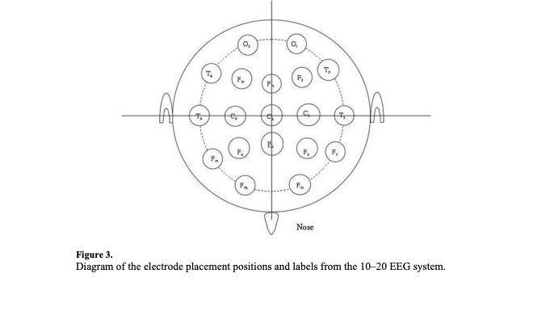

This new system for locating F3 requires the administrator to plug three measurement values into a free, stand-alone computer program.

**Takes in 3 inputs: Tragus to Tragus (cm), Nasion to Inion (cm), Circumference (cm)**

**Nasion to Inion input:**

The first input into the computer program is the distance from nasion to inion, measured with a tape measure in cm

The administrator marks the halfway point on this line on the subject's scalp

**Tragus to Tragus input:**

He/she then measures from the left preaurical point to the right preaurical point. This measurement is entered into the program and the administrator marks the halfway point on this line as well.

The vertex can now be marked on the patient's head by the intersection of the two lines

**Circumference input:**

The last measurement the administrator takes is the circumference. The tape measure should be placed at the level of the eyebrow and pass over the inion for this measurement.

**Output:**

Once this value has been input into the program, it produces two output values

The first is the distance to a point (we'll call point-x) along the circumference from the centerline (in cm's) = (F3) Distance along circumference from midline (X)

the second is the distance (in cm's) from the vertex along a line intersecting point-x = (F3) Distance from vertex (Y)

The distance from the vertex specified by the computer program along a ray beginning at the vertex and intersecting point-x, will be the F3 location from the 10–20 system. = (BA43) Distance from vertex through tragus (Z)

**Equations:**

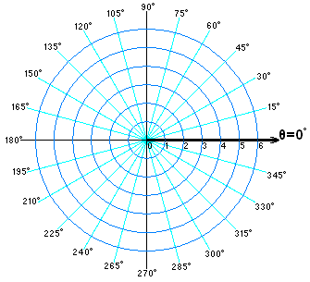

When looking at the basic 10–20 system one can create a coordinate plane and then find the equations of the two lines intersecting at the F3 location. Without loss of generality we will orient this coordinate plane with the nasion on 270° (the negative y-axis) and the inion on 90° (the positive y-axis) and the vertex in the center of the plane, as shown in figure 1.

Coordinate plane

Nasion = on 270° (the negative y-axis)

Inion = on 90° (the positive y-axis)

Vertex = in the center of the plane

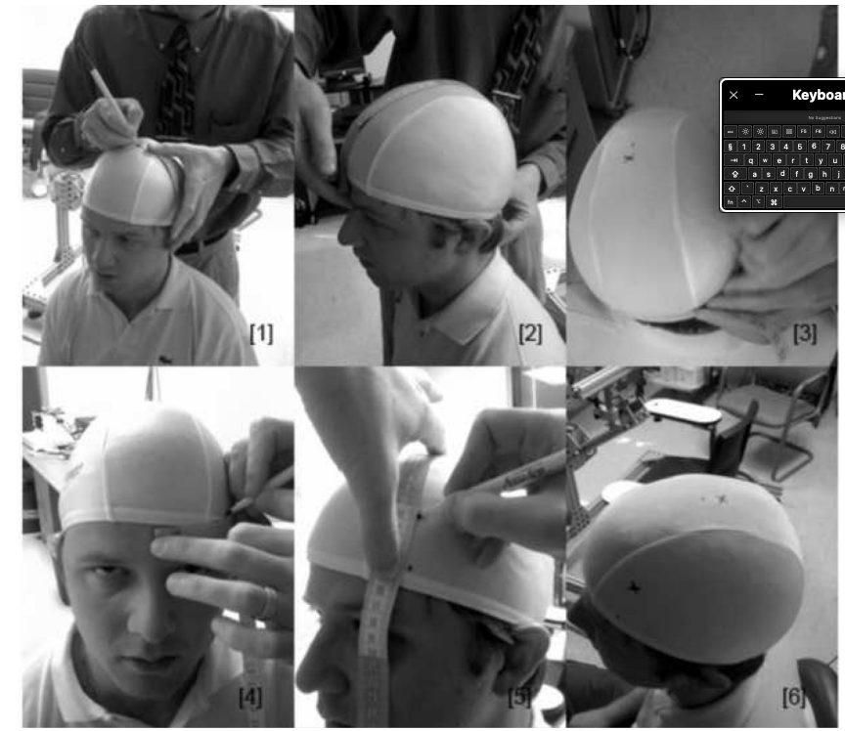

In mathematics, the polar coordinate system is a two-dimensional coordinate system in which each point on a plane is determined by a distance from a reference point and an angle from a reference direction. First, we find the polar coordinates of the four desired points, which will allow us to find the two equations of the lines intersecting at the F3 location.

We will let R1 be the distance from the vertex to the point Fpz. Likewise, we will let R2 be the distance from the vertex to the point T3.

The coordinates for the points Fz , F7, Fp1, and C3 are now intersected by an imaginary circle with radius R1.

Note that a point in the polar coordinate system is expressed as two coordinates: the radial coordinate and the angular coordinate

radial coordinate = the distance from the center of the plane and the point

angular coordinate = the angle of the ray beginning at the center and containing the point.

The angular coordinate is measured counter clockwise from the 0°ray (which is equivalent to the ray making up the positive half of the x-axis on the Cartesian plane)

The four points are expressed first as polar coordinates and then as Cartesian coordinates.

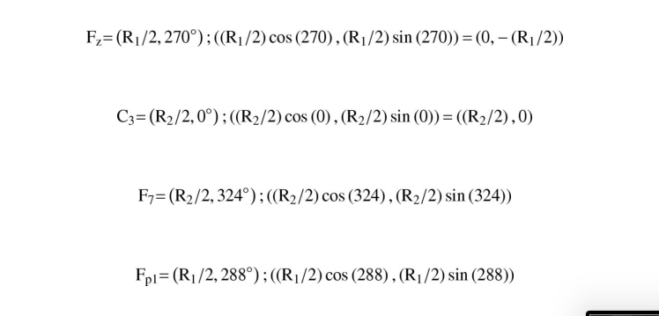

The equation to the line containing the points F7 and Fz is expressed in y intercept form as:

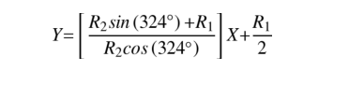

The equation of the line containing the points C3 and Fp1 is expressed in y intercept form as:

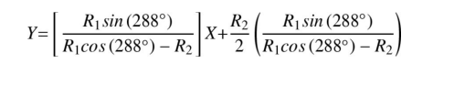

In order to find F3 we will set these two equations equal to one another, and then solve for x. Plug x into either of the first two equations and then solve for y. This will give you the following coordinates on the cartestian plane.

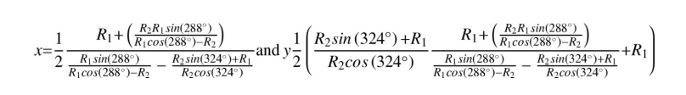

This pair of Cartesian coordinates must then be translated back polar coordinates

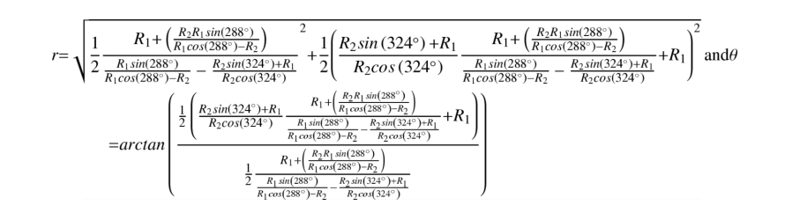

Now that we know the angle from the line from tragus to tragus, we will use its complementary angle in order to find the angle off of the midline. Let this new angle be Φ.

Then to find the distance(u) along the circumference(c) beginning at the midline we will use the following equation

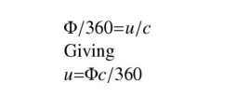

Clearly, the head is not a flat plane nor is it a sphere. The distance from the vertex to the nasion or any other points around the circumference will be much longer if measured along the scalp than the shortest distance between the two points. This is because of the curvature of the head.

The radius coordinate of the polar coordinates for F3 must now go through a small correction in order to account for this. When measuring from vertex to the desired location we have assumed that the head is a sphere; however, upon looking at this measurement, the line we are measuring is actually closer to being on a plane than a sphere. The following diagram illustrates the shortest distance between a and b is a straight line as shown. The distance of the arc along a circle going through a and b with its center at the origin is shown.

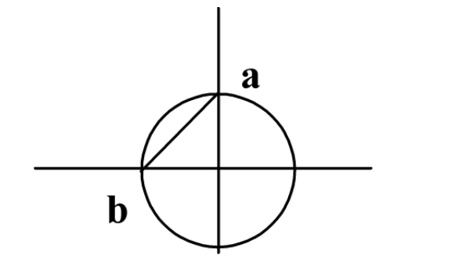

Unlike our measurements from the vertex to the inion, nasion, or trachus, the measurement from the vertex to the F3 location close to a straight line. Therefore, we must find the correction for this distance. Assuming the distance from a to the center and be to the center are the same, say r, the distance from a to b is given by r(2)1/2. Whereas arc length from a to b will be given by (0.25)2π r = π r(0.5). Now to find the correction factor q we will solve for q in the following equation

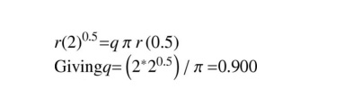

Thus we multiply the radius coordinate of the polar coordinates for F3 by 0.9 in order to account for the head not being a sphere.

Step 1: take time to understand the maths (equations of lines, co-ordinates)

Step 2: find out how to translate the maths in python

Step 3: write the software

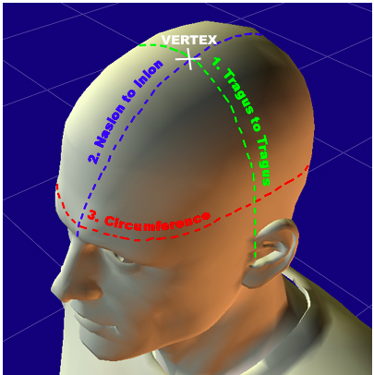

**What have you learnt?**

**Trying ot figure out how all variables are related to eachother in order to create the calculations that turn the input into the output ive learnt about/brushed up on, the polar coordinate system, radius of circles, how the 10-20 EEG system is used with the % marks/distances, how to use equations of lines to find a pont, cartesian coordinates**

**Coding = how to calculate complex maths equations which involve trigonometry, turning radian to degrees, how to use classes/object orientated programming**